# Wrong information in Analyst report:

2023_Transcript:

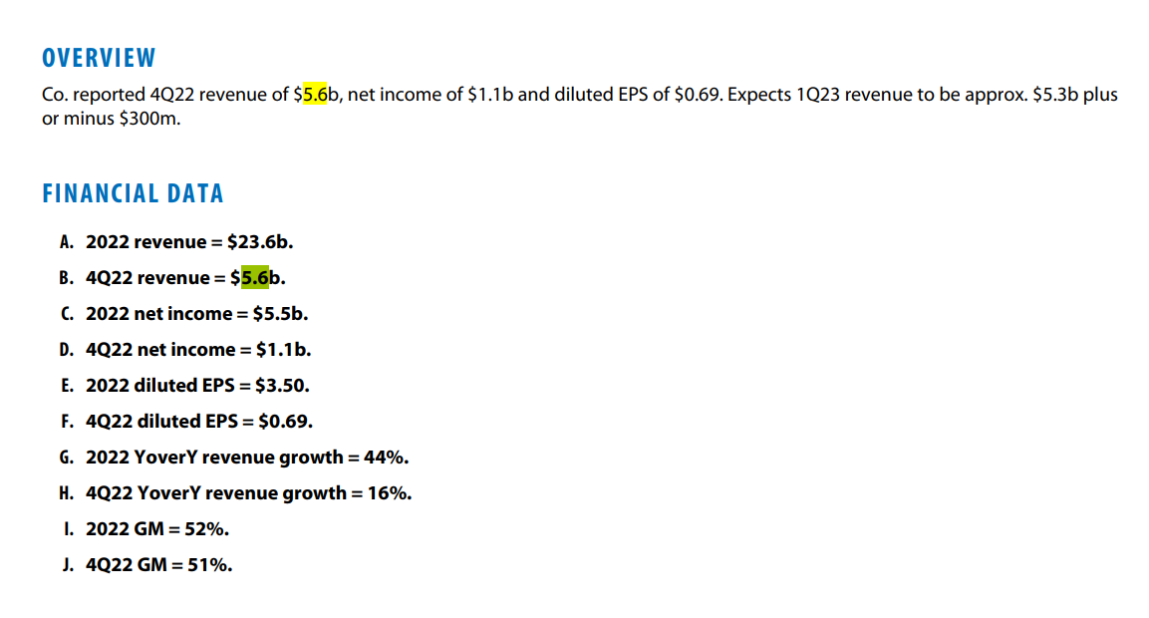

Rosenblatt:

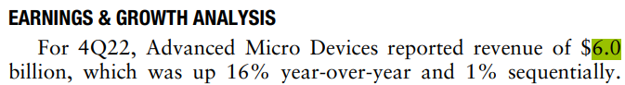

LLM Text: *sentence_2: For 4Q22, Advanced Micro Devices reported revenue of $6.0 billion, which was up $16% year-over-year and $1% sequentially.*

*→ GPT Bewertung: Contradicted*

*Reason: The knowledge base states 4Q22 revenue was $5.6B with 16% YoY growth, whereas the snippet asserts $6.0B revenue (and 1% sequential growth). The $6.0B figure directly conflicts with the KB data.*

Non-GAAP operating margin was 22.5% for 3Q22, vs. 22.7% for 3Q22 and 27.5% a year earlier



Rosenblatt:   


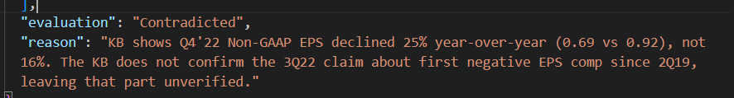

4Q22 Presentation:

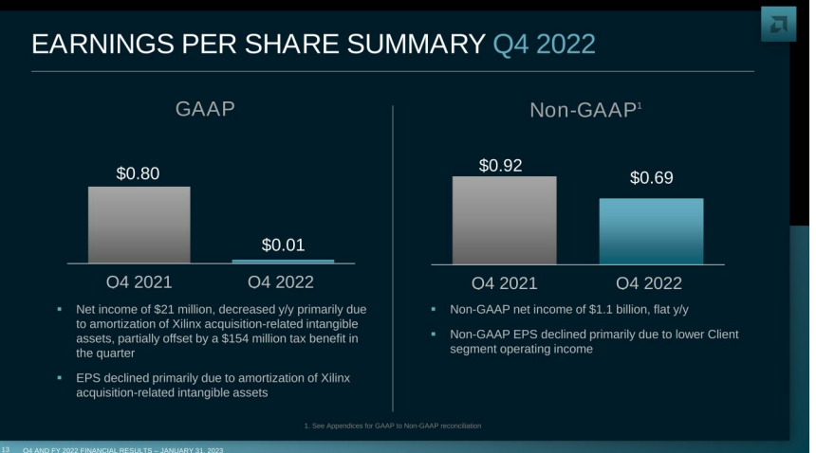

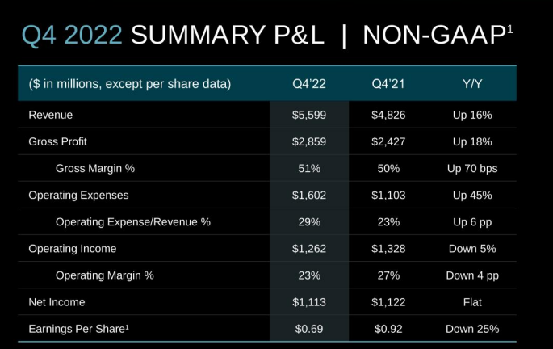

* Down 25%, not 16%.

# Wrong classification of the LLM:



Partially supported: Ist oft eine Mischung aus aktuellen Zahlen und der Veränderung von Vorjahr. (declined 1% sequentially…)

# DSRAG Pipeline – Performance

**Out of 40 queries: 1 error:**

**Claim 9:** Simultaneously, AMD is supporting both stand-alone CPU and GPU lines as well as its APU line that combines compute and graphics processing on a single die.  
**Evaluation:** No Evidence  
**Analysis:** The FY 2022 10-K describes AMD's products, including CPUs, discrete GPUs, and APUs (which integrate CPUs and GPUs). It confirms the existence and nature of these product lines. However, the specific phrasing "simultaneously... supporting" these lines is not present and is a summary of the business model. *Correction: The FY 2022 10-K clearly describes the product portfolio: "CPUs, accelerated processing units (APUs) that integrate CPUs and GPUs... discrete GPUs." This provides strong evidence for the claim.*  
**Conclusion:** The evaluation of "No Evidence" is incorrect; the claim is supported.

Wrong split in sentences:  
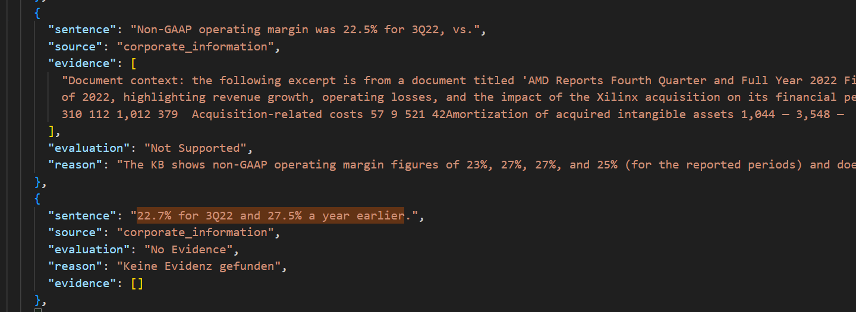

# Bemerkungen zur Informatonsabdeckung:

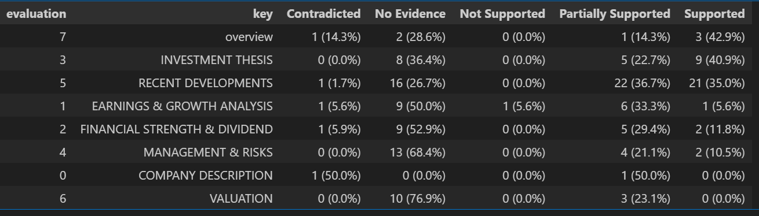

Financial Strength & Dividend: (Information über Cash und Dept des Unternehmen, sollten der Pipeline als Informationen vorliegen (im Idealfall):

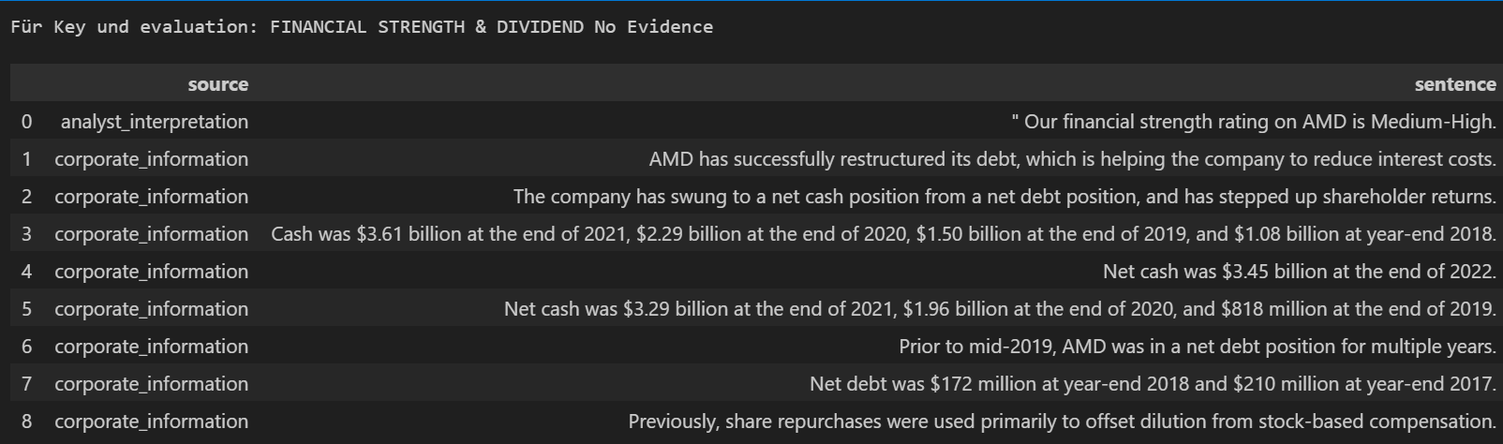

What analysts do:

Management & Risk (Ökonomisches Wissen):

|  |
| --- |
| A main risk for AMD, as for other semiconductor companies, is the possibility of a general economic downturn and a corresponding dip in technology hardware sales due to inflation and rising interest rates. |
| We believe that AMD has the financial strength, market leadership, and growth characteristics to weather this storm and emerge a stronger player. |